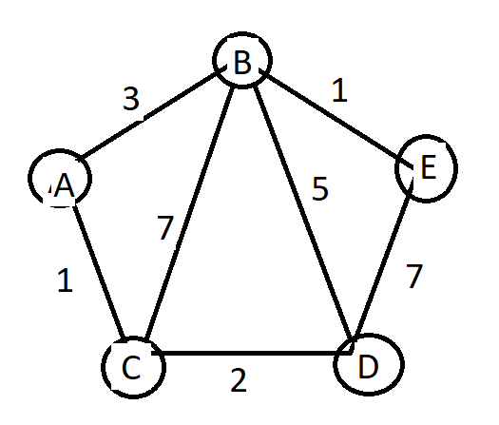

Adjacency matrix:

0 3 1 0 0  
3 0 7 5 1  
1 7 0 2 0  
0 5 2 0 7  
0 1 0 7 0

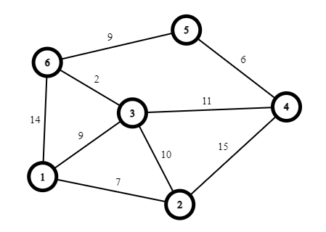

Adjacency matrix :

0 7 9 0 0 14  
7 0 10 15 0 0  
9 10 0 11 0 2  
0 15 11 0 6 0  
0 0 0 6 0 9  
14 0 2 0 9 0

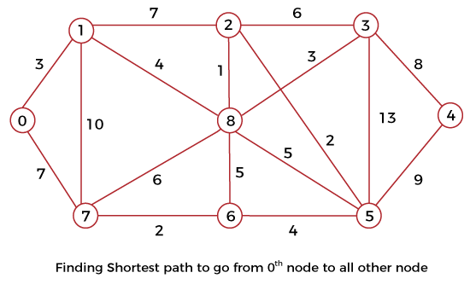

Adjacency matrix:

0 3 0 0 0 0 0 7 0  
3 0 7 0 0 0 0 10 4  
0 7 0 6 0 2 0 0 1  
0 0 6 0 8 13 0 0 3  
0 0 0 8 0 9 0 0 0  
0 0 2 13 9 0 4 0 5  
0 0 0 0 0 4 0 2 5  
7 10 0 0 0 0 2 0 6  
0 4 1 3 0 5 5 6 0